# How to Deploy the Web Application

1. Pull the Show-Me files from our Repository. The URL, <https://github.com/bloslo/show-me>
2. Execute “NPM Install” command on the project folder (You can use CMD). It’s required to download the required modules

.

1. A folder with name **“node_modules”** will be created containing the required modules.

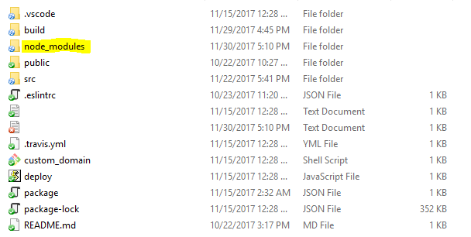

1. Execute “**NPM Run Build**” command on the project folder (You can use CMD). It’s required to build the deployment file.



1. A folder with name **“build”** will be created.

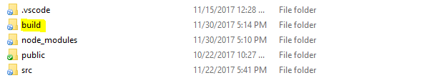

1. Upload the files inside the “**build**” folder to your host/server. You can use any FTP program. In this case, CyberDuck is used. (the last 3 folders are blackened as they are not required)

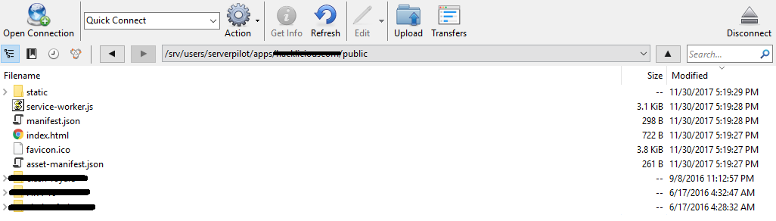

1. The Web Application is running on your hosting/server.

